University of California Davis Health

Request for Quotation

RFQ Bed Lifts – Replacement Hospital Tower Bed Lift Units
Request for Quotation #: RFX00055
Date Issued: July 27, 2026
Due Date: August 5, 2026
Submitted by the University of California Davis Health
This RFQ is also available at: UC Davis Health Supply Chain Open Solicitations page
All questions regarding this RFQ should be directed to:
Daniel Schroeder
UCDH Procurement and Strategic Sourcing Department
Email: dschroeder@health.ucdavis.edu
Phone: (916) 734-3225
Questions should not be directed to any other University departments or staff. Material or substantive information provided to any bidder, as result of questions received, will be provided to all bidders via an addendum to this RFQ.

Disclosures
Deviations from specifications: Any deviation from the specifications shall be identified and fully described. UC Davis Health reserves the right to accept or reject quotations on each item separately and/or waive any irregularities in the quotation; irregularities may, however, render the quotation non-responsive.
Public disclosure: Responses Become Public Records: All materials submitted in response to this solicitation become a matter of public record and shall be regarded as public record.
Designation of Confidential Information: The Regents will recognize as confidential only those elements in each response, which are trade secrets as that term is defined in the law of California and which are clearly marked as “TRADE SECRET,” “CONFIDENTIAL,” or “PROPRIETARY.” Vague designations and blanket statements regarding entire pages or documents are insufficient and shall not bind The Regents to protect the designated matter from disclosure.
California Public Records Act: The California Public Records Act limits The Regents’ ability to withhold prequalification and bid data to trade secrets or records, the disclosure of which is exempt or prohibited pursuant to federal or state law. If a submittal contains any trade secrets that a Bidder does not want disclosed to the public or used by The Regents for any purpose other than evaluation of the Bidder’s eligibility, each sheet of such information must be marked with the designation “Confidential.” The Regents will notify the submitter of any request to inspect such data so that the submitter will have an opportunity to establish that such information is exempt in any proceeding to compel inspection.
The Regents Not Liable for Required Disclosure: The Regents shall not in any way be liable or responsible for the disclosure of any records if they are not plainly marked “TRADE SECRET,” “CONFIDENTIAL,” or “PROPRIETARY,” or if disclosure is required by law or by an order of the court.

Section I – RFQ Instructions and Timeline

Quote Submittal Instructions
Each Bidder is required to submit the provided Excel Cost Proposal RFQ by email to Daniel Schroeder at dschroeder@health.ucdavis.edu. Please include “RFQ Replacement Hospital Tower Bed Lift Units” in the subject line.
All Quotes submitted must be received in the UCDH email inbox of dschroeder@health.ucdavis.edu no later than 5:00 PM PST as per the RFQ Schedule of Events. UCDH Purchasing Department will not accept Quotes received after the due date and time.

RFQ Schedule of Events
Table 1. RFQ Schedule of Events
Event | Date
Release of Request for Quotations | Monday, July 27, 2026
Deadline for Submission of Written Questions or Request for Clarification | Friday, July 31, 2026, 5:00 PM PST
Responses to Written Questions | Monday, August 3, 2026, 5:00 PM PST
Deadline for Submissions of Quotations | Wednesday, August 5, 2026
Completion of Quotations Evaluation* | Friday, August 7, 2026
*These are approximate dates and subject to change.

Basis of Award
California Public Contract Code Section 10507 et seq. requires that all purchase contracts and/or agreements involving an expenditure of more than $100,000 annually be awarded to the lowest responsible bidder meeting specifications, or else all bids be rejected. Lowest responsible bidders may be determined based on one of two bid evaluation methodologies: (1) cost alone, or (2) best value.
This bid shall be evaluated based on cost alone. Pricing must be complete and include all costs necessary to furnish fully operational systems meeting the Section III “Required” elements.
UCDH reserves the right to: (1) waive any immaterial defect or informality; or (2) reject any or all submissions or portions thereof; or (3) reissue a RFQ when UCDH determines that it is in its best interest to do so; (4) make an award to more than one vendor if in the best interest of UCDH to do so; and (5) evaluate quotations based on cost of ownership elements including equipment acquisition cost, installation cost, warranty, and service/maintenance costs.
Resulting agreement will incorporate the terms, conditions, and requirements set forth in this RFQ.

Section II – Background Information

Project Background and Objectives
UC Davis Health (UCDH) is soliciting Quotations for vertical bed lift units for the Replacement Hospital Tower (“California Tower”) new construction. Units will be installed in the lower level (basement) structure of the building as provided on the computer-assisted design (CAD) drawings posted on the Open Solicitations page. Access for winning bidder to the installation sites is included in the attached drawings.

Section III – Request for Quotation Format

Introduction
Please read the following carefully. Failure to prepare proposals in the following required format may result in elimination from the evaluation process.

Acknowledgement
Each bidder is required to acknowledge their agreement to the documentation format and terms in Exhibit A and Appendix A listed below and attached for reference on the Open Solicitations page. Utilize the acknowledgement provided in Section IV – Acknowledgement and Authorized Signature, page 6 below.
- Exhibit A – UC Health Purchase Agreement
- Appendix A – UC Terms and Conditions-04-01-25

Exhibit B Cost Proposal
Please provide all requested information in a brief but complete response, responding in order and identifying each response by the corresponding question number in the provided Excel Cost Proposal file.
All items must be addressed in response.
Items under the “Required” heading list specifications that must be met as an absolute, non-negotiable requirement.
Items under the “Conditional” heading must be responded to as needed information for equipment installation and ownership and/or is adaptable based on capabilities for the winning bidder.
Supporting documents to describe bidder’s equipment, services and quotation may be submitted as Adobe PDF files but do not replace response on the Excel Cost Proposal file.

Required
- 14 total bed lift units
- 3 carrier platform (bed) capacity
- Front loading units
- Minimum bed storage dimensions limit per carrier platform: 95 inches length, 44.5 inches width, 26 inches height
- Maximum unit (machine) dimensions: 120 inches length, 55 inches width, 100 inches height
- Minimum unit (machine) carrier platform weight capacity: 600 pounds (1800 pounds minimum unit total weight capacity)
- Bridge plate adapters for each carrier platform
- Carrier platform loading ramps
- Adjustable carrier platform wheel stops
- Single phase, 220 volt, 15 amp, 60 hertz electrical demand
- Additive components for seismic anchoring (if any)
- Free-on-board (FOB) destination/delivery duty paid (DDP) shipment to Sacramento, California warehouse location managed by McCarthy Builders
- Re-palletization of equipment components in provided warehouse space for unit transportation to installation space (see Section V included job site elevator information)
- Transportation of equipment components from offsite delivery (truck) location to installation space (see Section V included job site path of travel schematic)
- Engineering and structural installation plan drawings and calculations
- Installation by union represented tradespersons to meet local/state/federal regulatory standards (see Section V included installation site drawings)
- Warranty to commence on facility first patient use (expected calendar year 2030)

Conditional
- NEMA plug socket outlet requirement (to be installed by other)
- Dedicated/isolated electrical circuit amperage per outlet requirement
- Total unit weight
- Carrier platform drive system motor horsepower
- Initial warranty period (duration)
- Service/maintenance plan coverage and cost options
- Owner performed preventative maintenance guide
- Training offered to equipment users, biomedical engineering and/or plant operations & maintenance personnel for required owner service, inclusive of cost (if any)
- Payment terms
- Accessories, options and parts listing beyond the stated requirements

Section IV – Terms and Conditions

Quote Conditions
Notwithstanding any other provision of the RFQ, bidders are hereby advised that this RFQ is solicitation of quotes only and is not to be construed as an offer to enter into any contract or agreement. Thus, UCDH reserves the unqualified right to reject any or all quotes for any reason.
UCDH shall have the unconditional and unqualified right to withdraw, cancel, or amend this RFQ at any time.
UCDH reserves the right to interpret or change any provision of this RFQ at any time prior to the quote submission date. Such interpretation or change shall be in the form of a written addendum to this RFQ.
Prior to the final submission date, any bidder may retrieve its quote to make additions or alterations. Such retrieval, however, shall not extend the final submission date.
Bidders wishing to submit quotes in response to this request do so entirely at their own expense, and submission of a quote indicates acceptance of the conditions contained in the RFQ unless clearly and specifically noted otherwise.
Bidders may not distribute any announcement or news release regarding this project without written approval by the University of California, Davis Health. Any materials to be provided to regulatory agencies, other entities, or to the public shall be submitted to UCDH for review and distribution unless otherwise directed by a UCDH representative.
All materials submitted in response to the RFQ will become the property of UCDH. All samples of work submitted as part of this quote will be returned at the request of the bidder. Materials may be returned, with the exception noted above for sample material, only at UCDH’s option and at the bidder’s expense.
Successful awardee will be required to extend pricing and terms of the agreement to all UC locations.
All pricing proposed in the bidder submission shall be firm for UCDH issuance of purchase order.
Bidder Commitment to Sustainability: UC is committed to responsible stewardship of resources and to demonstrating leadership in sustainable business practices and thus will require Bidders to present their commitment to sustainable practices as it applies to its goods and services.

Acknowledgement and Authorized Signature
Please complete the vendor contact information requested below:
Table 2. Vendor Contact Information
Field | Response
Company Name
Federal Employer Identification Number
Main Phone Number
Contact Person and Title
Contact Email Address
Contact Phone Number
I certify that I am authorized to sign on behalf of the organization I represent for this offer and agree to all terms and conditions described herein.
Table 3. Authorized Signature
Field | Response
Authorized signature
Date

Section V – Additional Information
Installation site/ job site path of travel/ job site elevator information
Path of travel and elevator access overview for building installation site.
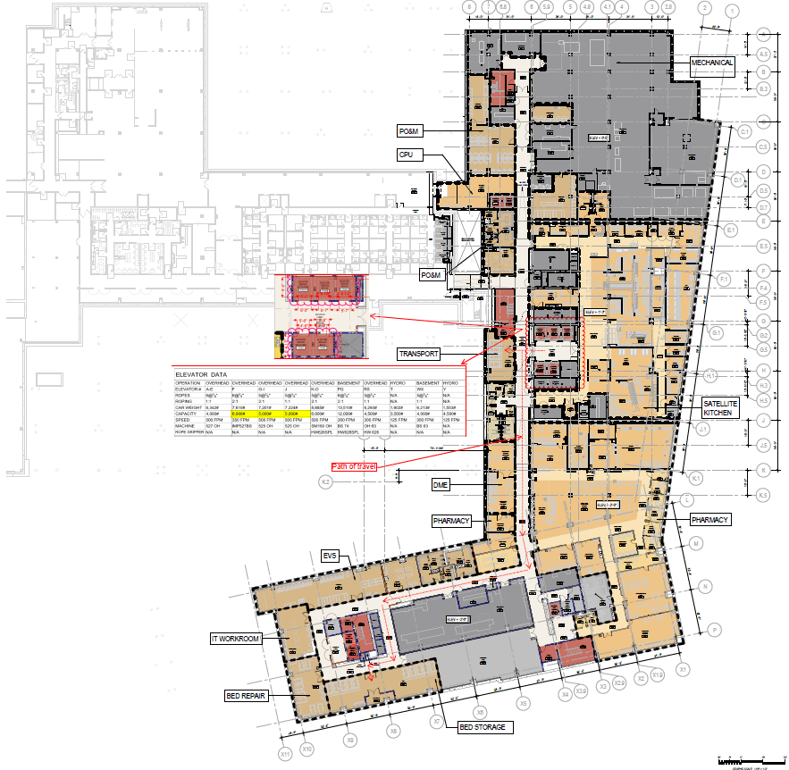

Zoom detail to installation location for 4 of 14 units, marked “Transport” on overview schematic.

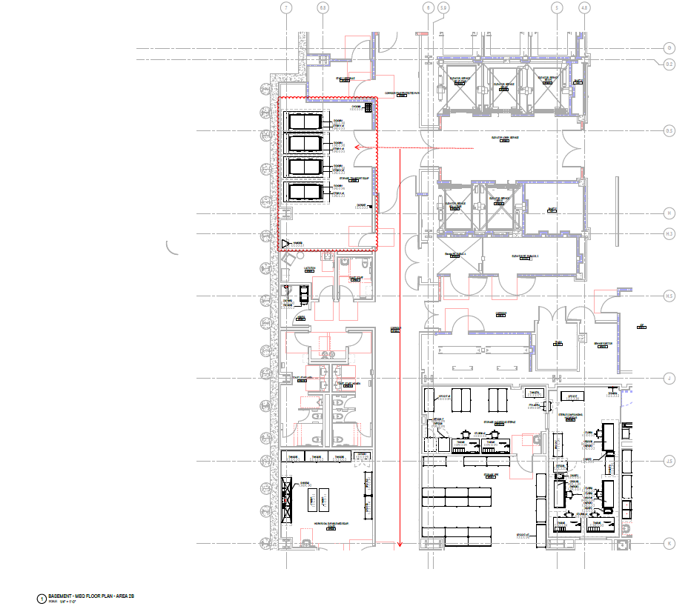

Zoom detail to installation location for 5 of 14 units, marked “Bed Storage” on overview schematic.
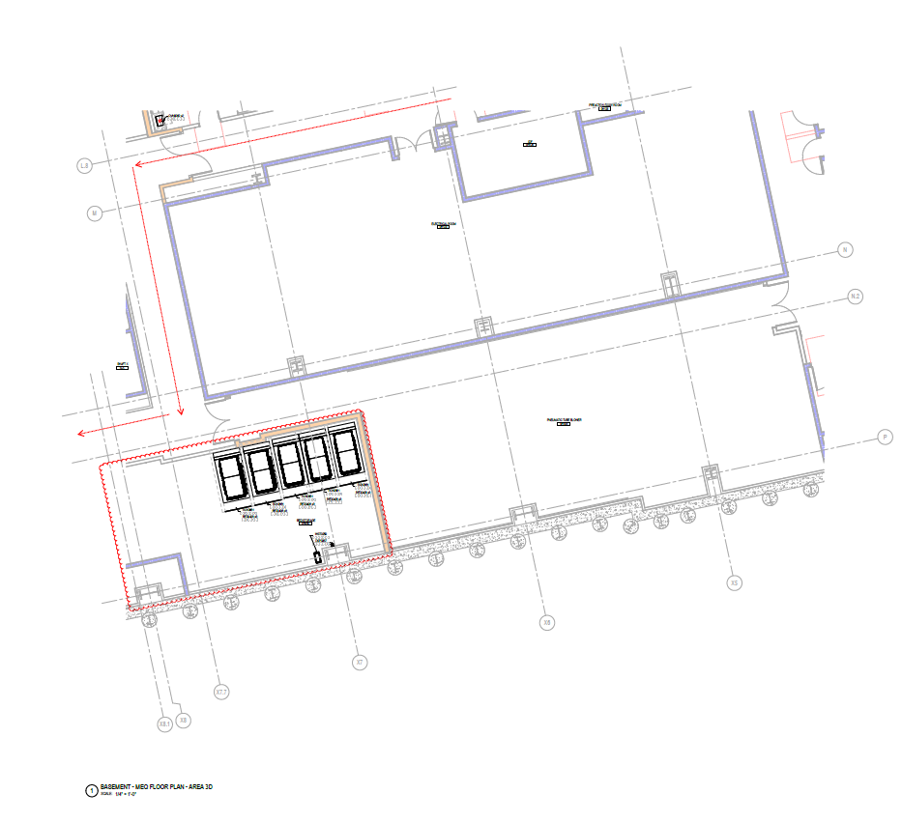

Zoom detail to installation location for 5 of 14 units, marked “Bed Storage” on overview schematic.

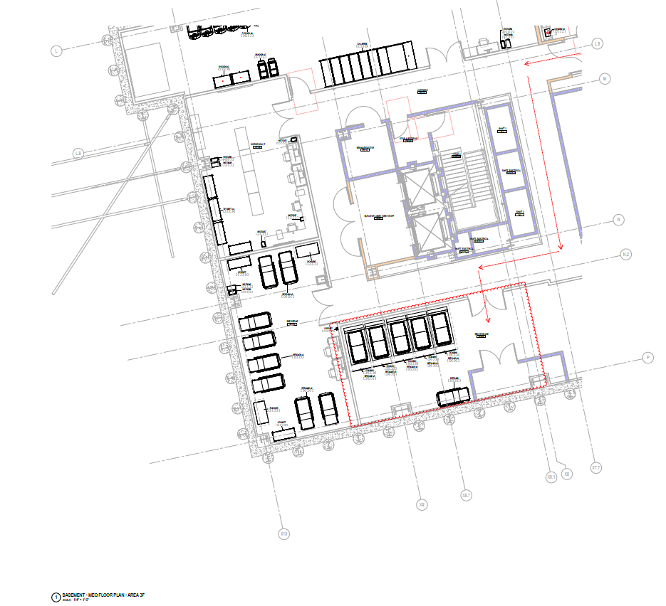

Zoom detail to elevator information on overview schematic.

